Recap:

Conventional Per Phase Equivalent Circuit:

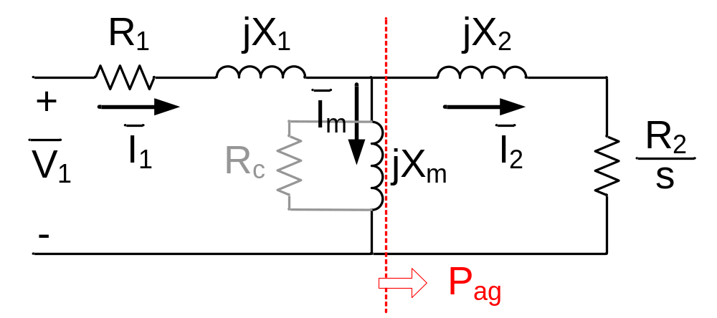
Per Phase Equivalent Schematic of Induction Motor Reflected to Stator

Reduced Voltage Operation:

T_{em} α V²

Speed [pu] | 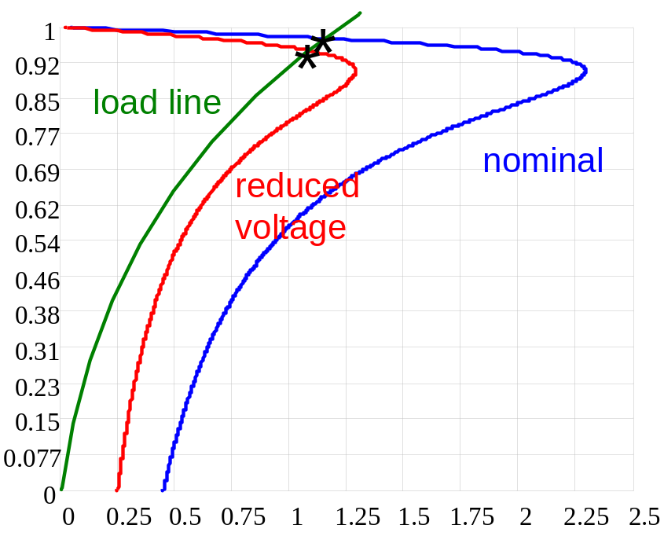
 | Torque [pu]
Reduced Voltage Operation of Induction Motor

Constant Volts/Hz operation:

Z_{in} = R₁ + j ω_{e} L_{ls} + j ω_{e} L_{m} //

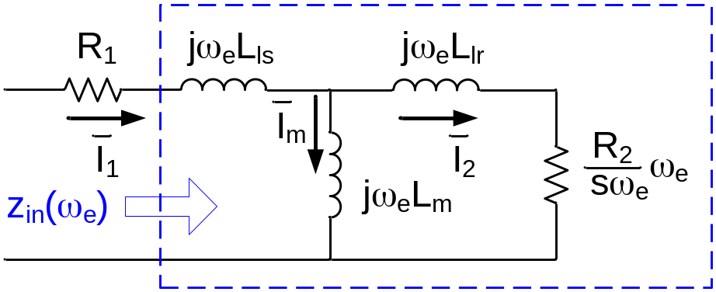
Induction Motor Per Phase Equivalent Circuit

Neglecting R₁:
Z_{in}(ω_{e}) = j ω_{e} L_{ls} + j ω_{e} L_{m} //

T_{em} = 3

Maintain constant V/f:
- Maintains circuit (machine) impedance
- Maintains stator current
- Maintains rotor current (and thus torque)
- Maintains magnetizing current (and thus flux)

Speed [pu] | 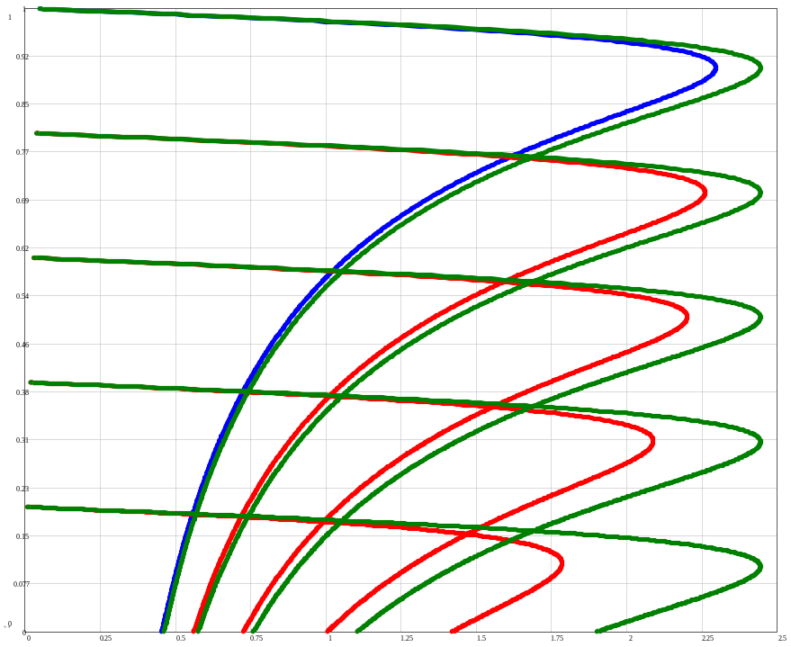 | 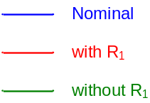
 | Torque [pu]
Induction Motor Speed Torque Curves with Constant V/Hz

Stator resistance causes deviation from ideal→ use voltage boost to (partially) compensate

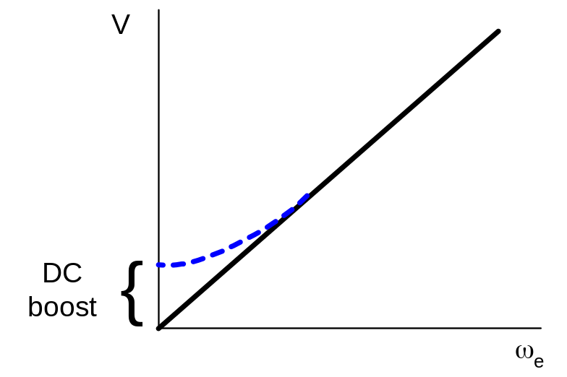
Typical Voltage Boost Strategy for V/Hz Drives

Speed [pu] | 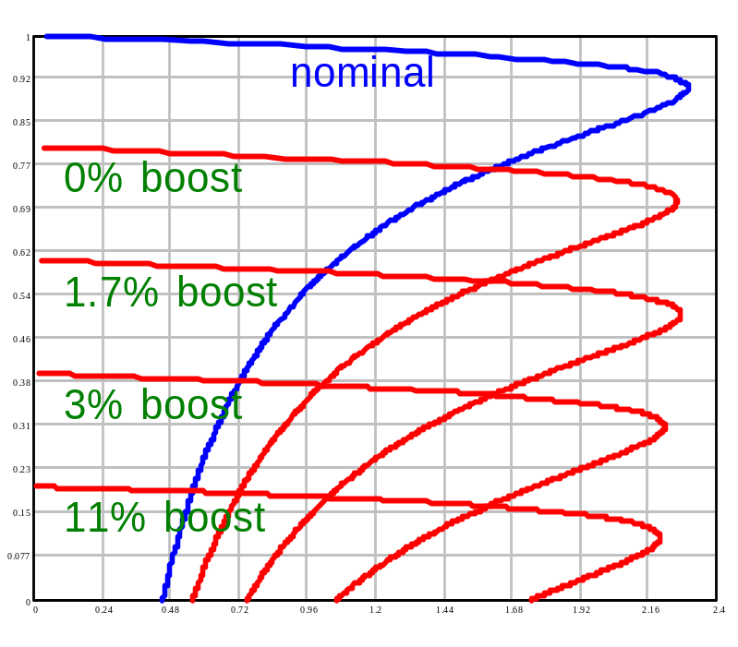
 | Torque [pu]
Induction Motor Speed Torque Curves with Constant V/Hz with Boost

Above base speed (voltage)
Speed [pu] | 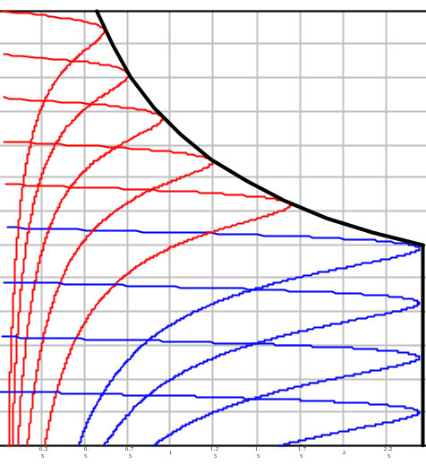
 | Torque [pu]
Induction Motor Capability Curves

Coupled Circuit Modeling of AC Machines:
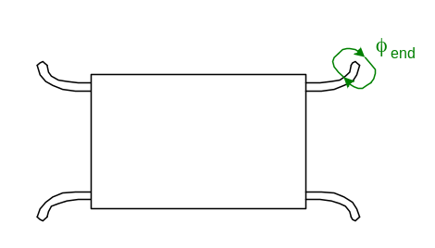

Begin with uniform airgap idealized model
Assumptions:
- uniform airgap
- ideal iron
  - infinite permeability
  - no core loss
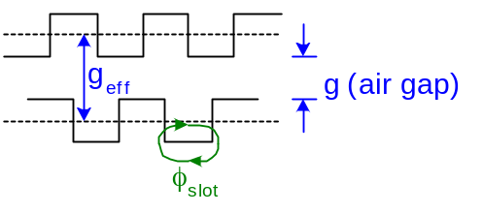
- no end effects
- no slotting effects

Note: assumptions 2,3, and 4 are handled by adding “correction terms”

Winding Inductances:
sinusoidal distribution

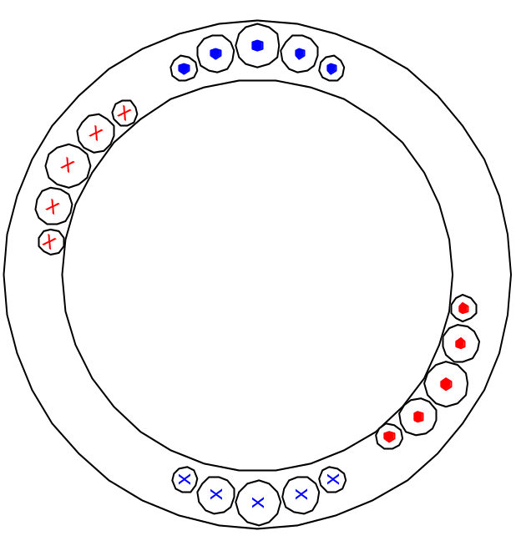 | Winding Inductances:  λ_{a} = L_{aa} i_{a} + L_{ab} i_{b} + L_{ac} i_{c} + …  L_{aa} = |i_{b} = i_{c} = … = 0  L_{ab} = |i_{a} = i_{c} = … = 0
Sinusoidally Distributed Stator and Rotor Windings

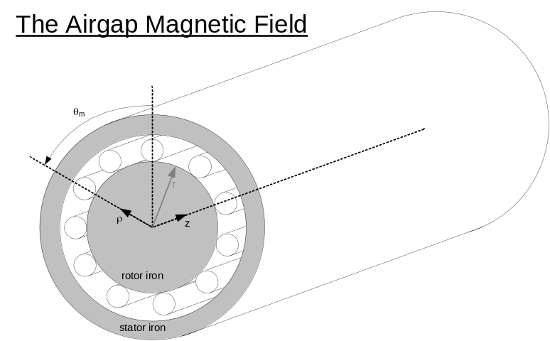 | Cylindrical Coordinate System chosen for simplicity  Coordinates: ρ, θ_{m}, z  z-axis chosen along axis of machine  with ρ = r (rotor radius), θ_{m} defines a point in the air gap

In general, H = H(ρ,θ_{m},z) - Magnetic Field Intensity in air gap will be a function of, or in other words, have components in each of the three directions. Since we’re concerned with finding the flux linking a winding placed upon the surface of the rotor or stator, only the component normal to the surface (radial component) is significant. We need to find the radial component of H(ρ,θ_{m},z).

With assumption #3 (no end effects), magnetic field intensity is independent of the z coordinate.
H = H(ρ,θ_{m}).

If r >> g (rotor radius much greater than air gap), variation with ρ will be negligibly small. Therefore, H = H(θ_{m}).

Ampere’s Law:

H = J = current enclosed
any closed path
current density
surface area
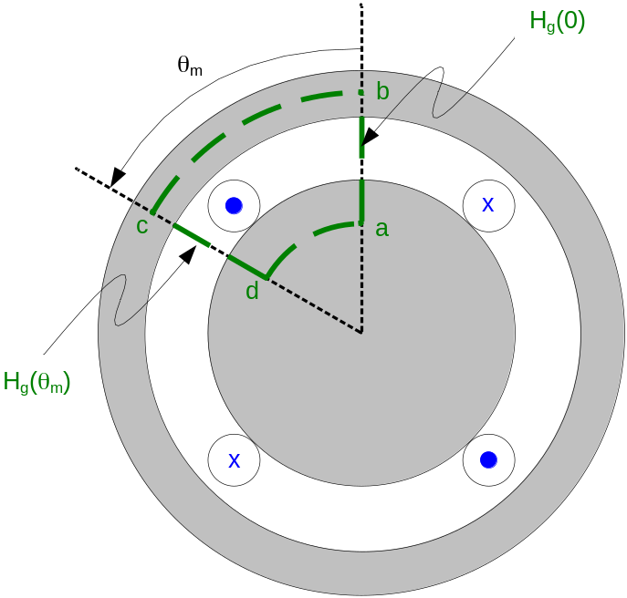 | Integrate along abcda  Note: H_{bc} & H_{ad} must equal zero with assumption #2a (infinite permeability).  Along air gap portions of path, MMF is simply air gap length (g) times air gap field intensity (H_{g}). Choose reference to be positive for H_{g} directed inward.

g[H_{g}(θ) – H_{g}(0)] = current enclosed = η(θ) i
net number of conductors carrying positive
current
Radial component of air gap field intensity at θ_{m}

Note: η(θ) is dependent upon where you start

Guass’ Law:

B = μ_{o} H = 0
(total flux crossing air gap, or leaving rotor, is zero)

dA = r dθ_{m} d_{z}
arc length
B = B_{g}(θ_{m}) r dθ_{m} d_{z} = r l B_{g}(θ_{m}) dθ_{m} = μ_{o} r l H_{g}(θ_{m}) dθ_{m}

from above

H_{g}(θ_{m}) = η(θ) + H_{g}(0)

constant

dθ_{m} = 0 → dθ_{m} + 2 π H_{g}(0) = 0

H_{g}(0) = - = - AVG

therefore H_{g}(θ_{m}) =

define N(θ_{m}) = (called the winding function)

then

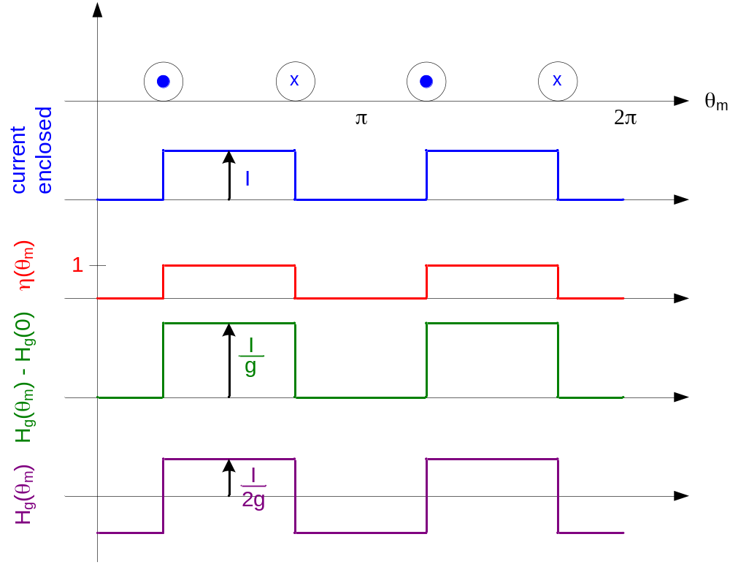
AVG
Winding Function from Winding Distribution Above

Example:

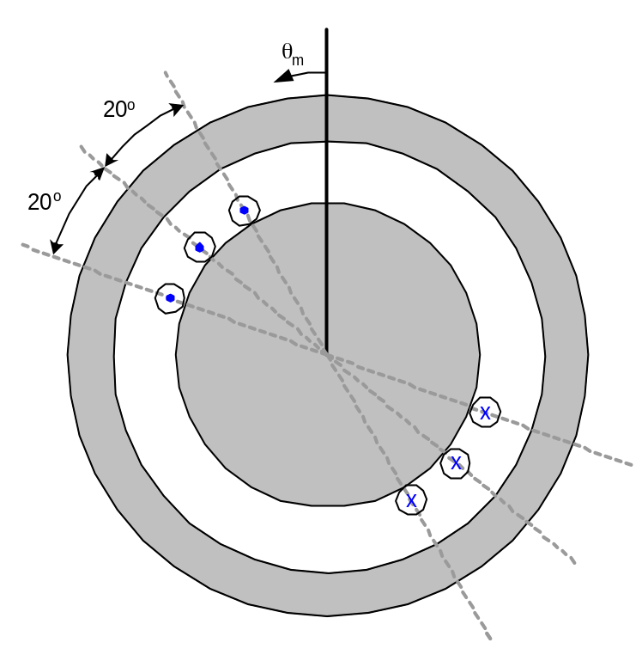 | One phase of a three phase winding  3 slots/pole/phase (18 slot stator)

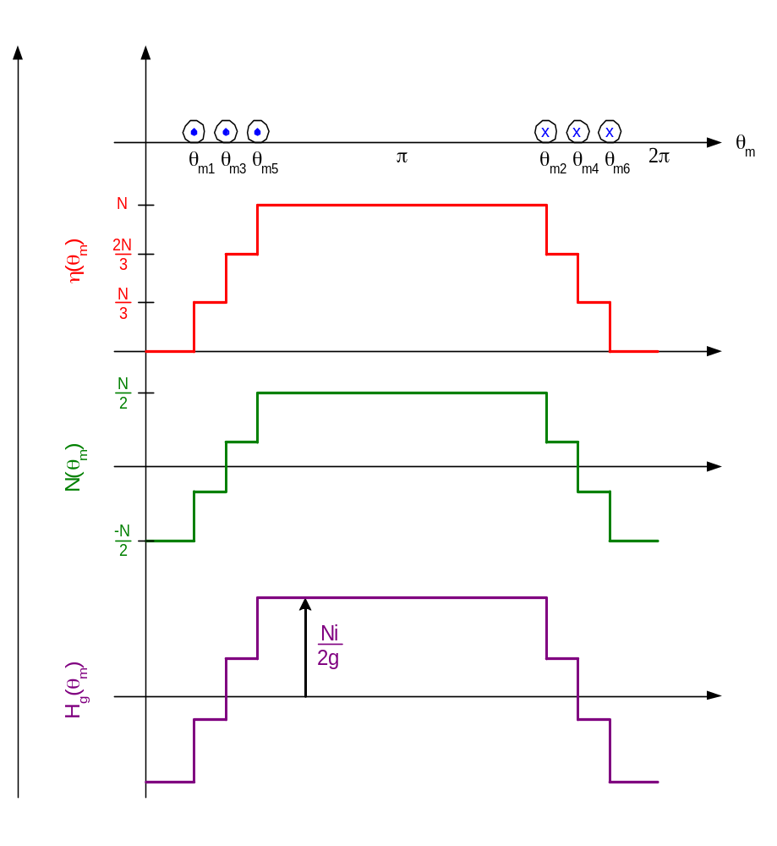

Peak value of N(θ_{m}):

N_{pk}(θ_{m}) =

Flux Linkage and Inductance:

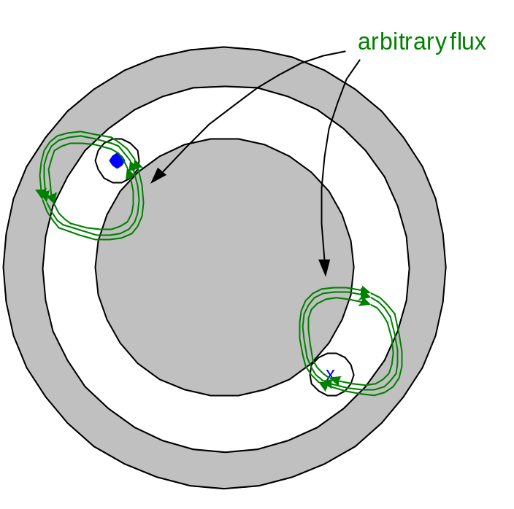
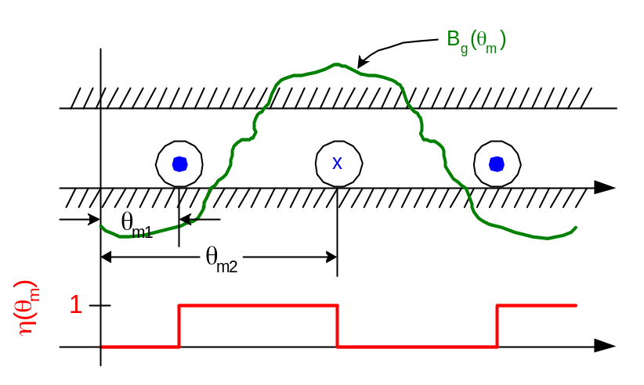

λ = r l B_{g}(θ_{m}) dθ_{m} = - r l B_{g}(θ_{m}) dθ_{m} (coil defined in opposite direction)

λ = r l B_{g}(θ_{m}) dθ_{m}

Counting Function

from previous example:

λ = r l

= r l

= r l B_{g}(θ_{m}) dθ_{m}

but this is dependent upon where we choose our reference

N(θ_{m}) = → η(θ_{m}) =

So

λ = r l B_{g}(θ_{m}) dθ_{m} = r l B_{g}(θ_{m}) dθ_{m}

= r l B_{g}(θ_{m}) dθ_{m} + r l AVG B_{g}(θ_{m}) dθ_{m}

for the case of self inductance, B_{g}(θ_{m}) is the field produced by the winding itself:

B_{ga}(θ_{m}) = μ_{o} H_{ga}(θ_{m}) = N_{a}(θ_{m})

The self inductance is therefore:

for Mutual Inductance:
B_{ga}(θ_{m}) = N_{b}(θ_{m})

Recall for machines with more than 2 poles to express quantities in electrical (rather than mechanical) radians, we have:

θ = θ_{m}

θ - electrical angle
θ_{m} – mechanical angle
P – number of motor poles

Concentrated Windings:

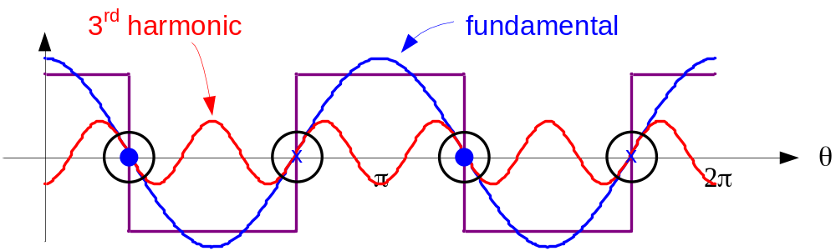
Winding Function for a Concentrated Winding

N(θ) = Np

space harmonics

Side note on space harmonics with induction machines:

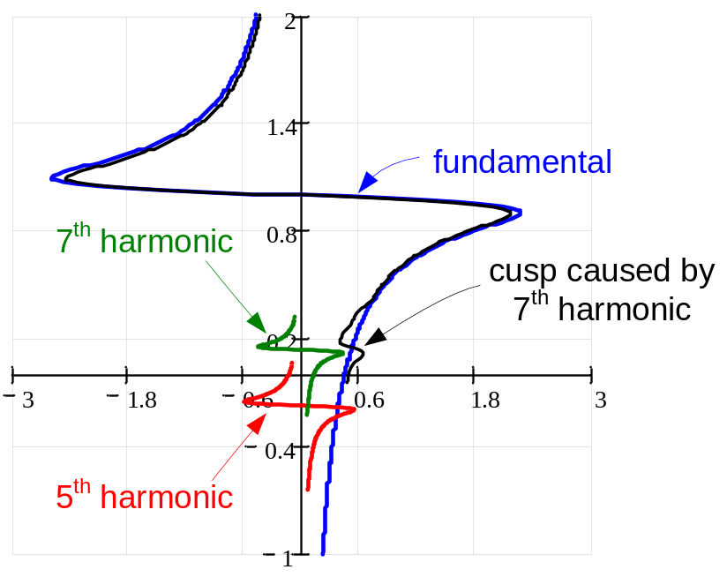
Speed Torque Curve of Induction Machine with Space Harmonics

Elimination of 3rd Harmonic:

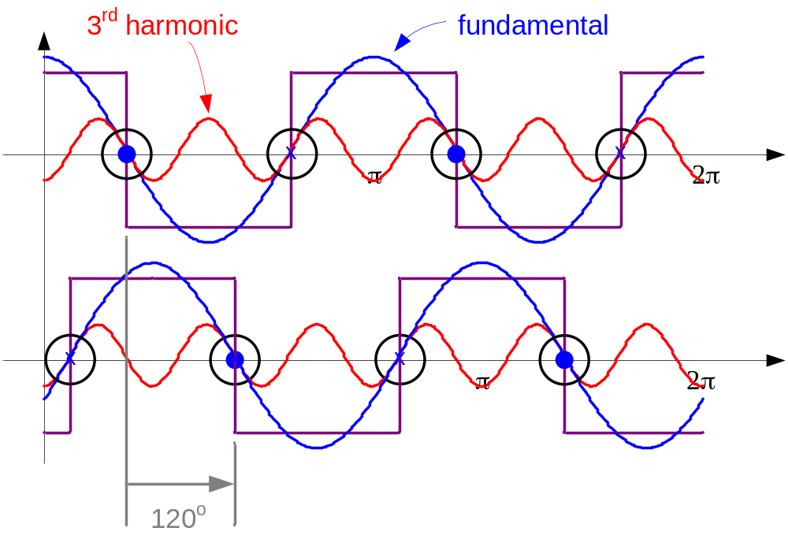
Winding Function for a Concentrated Winding of a 3 Phase Machine Showing 2 Phases

Displace turns by 120 (electrical) degrees to eliminate 3rd spatial harmonic
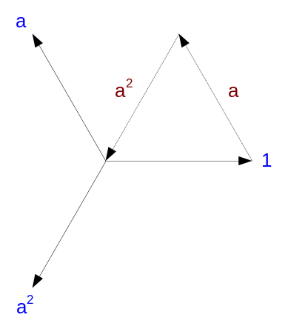
Typically
- No even harmonics (north pole is symmetric with south pole)
- Only sine or only cosine waves (1/4 wave symmetry)

N(θ) = N_{h} cos

For sinusoidal windings:
h θ_{m}
N(θ) = N_{h} cos

L_{h} = Nh cos²dθ_{m}

cos²dθ_{m} = dθ_{m} = π

Self Inductance

L_{hk} = N_{h} cos N_{k} cosdθ_{m}

= dθ_{m}

= 0 for h = k

There is no magnetic interaction between sinusoidal windings with different number of poles.

Mutual Inductances

N_{a}(θ) = N_{ha} cos(hθ + φ_{ha})

N_{b}(θ) = N_{hb} cos(hθ + φ_{hb})

L_{hab} = N_{ha} cos N_{hb} cos dθ_{m}

= cos

Mutual Inductance
angle between windings on fundamental scale

3φ Machine Model:

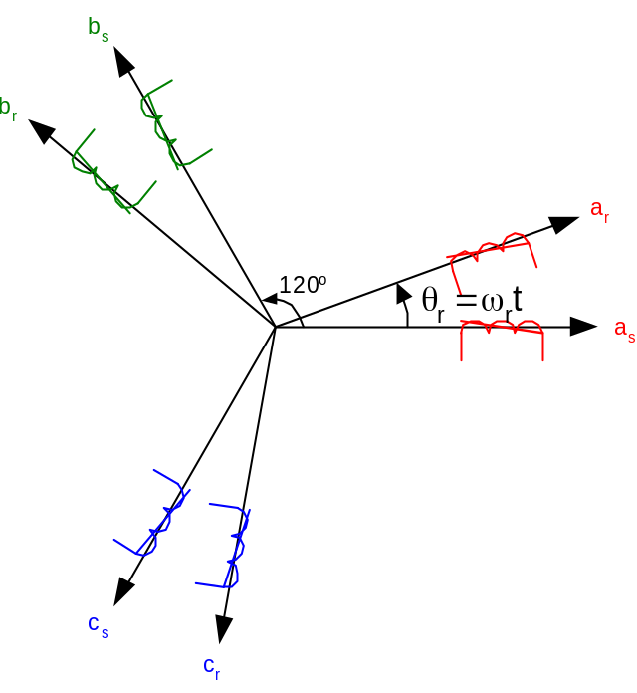
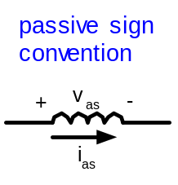
Space Vectors of a Three Phase Machine

- Assume sinusoidal winding distribution
N_{a}(θ) = N_{s} cos(θ)
N_{b}(θ) = N_{s} cos(θ – 120 º)
N_{c}(θ) = N_{s} cos(θ + 120º)

Note: Do not confuse phasors with space vectors (space vectors are spatial location of winding axis, phasors are temporal (time varying) vectors)

Example: for a time based system:
i_{a}(t) = I cos(ωt)
i_{b}(t) = I cos(ωt – 120 º)
i_{c}(t) = I cos(ωt + 120º)

Phasors:  I_{a} = I ∠0 º  I_{b} = I ∠−120 º  I_{c} = I ∠120 º | 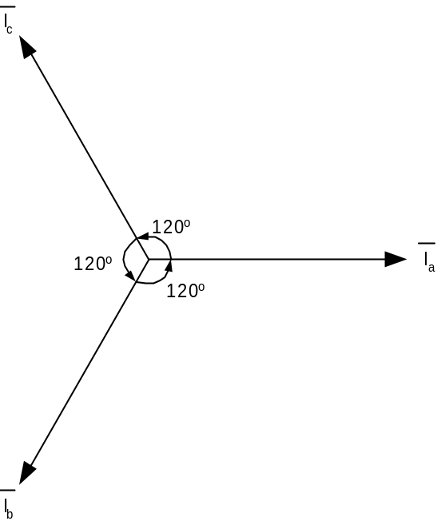
Phasor Representation of Temporal Signals

Total flux linkage for a 3φ machine in 1φ:

λ_{as} = L_{as} i_{as} + L_{abs} i_{bs} + L_{acs} i_{cs} + L_{asar} i_{ar} + L_{asbr} i_{br} + L_{ascr} i_{cr}

v_{as} = r_{s} i_{as} + p λ_{as} → voltage equation

with sinusoidal windings,

Stator Self Inductance:
L_{as} = Ns + L_{ls}

Ns = Magnetizing Inductance = L_{ms}

L_{ls} = Leakage Inductance (accounts for end turn, slot, etc.)

Stator Mutual Inductance (with other Stator Windings):
Note: Negative sign denotes flux from other winding is opposite in direction of produced by current in it’s own coil.

Stator Mutual Inductance (with Rotor Windings):
L_{asar} = N_{s} N_{r} cos → from L_{hab} = with h =1, δ = θ_{r}

Stator Voltage equation:

λ_{as} = L_{as} i_{as} + L_{abs} i_{bs} + L_{acs} i_{cs} + L_{asar} i_{ar} + L_{asbr} i_{br} + L_{ascr} i_{cr}

v_{as} = r_{s} i_{as} + p λ_{as}

= r_{s} i_{as} + L_{ls} p i_{as} + L_{ms} p +
L_{ms} p

p = cos(θ_{r}) p i_{ar} - i_{ar} sin(θ_{r})
transformer voltage
speed dependent voltage

Observations:
- These equations describe a set of nonlinear (because of product of current , position, and speed), coupled set of differential equations with time varying coefficients!
- Will show this is an 8th order (with mechanical system) nonlinear, cross coupled set of differential equations with time varying coefficients!
- Special case: = constant = ω_{r}

θ_{r} = ω_{r} t + θ_{ro}

equations are linear but still have time varying (periodic) coefficients

